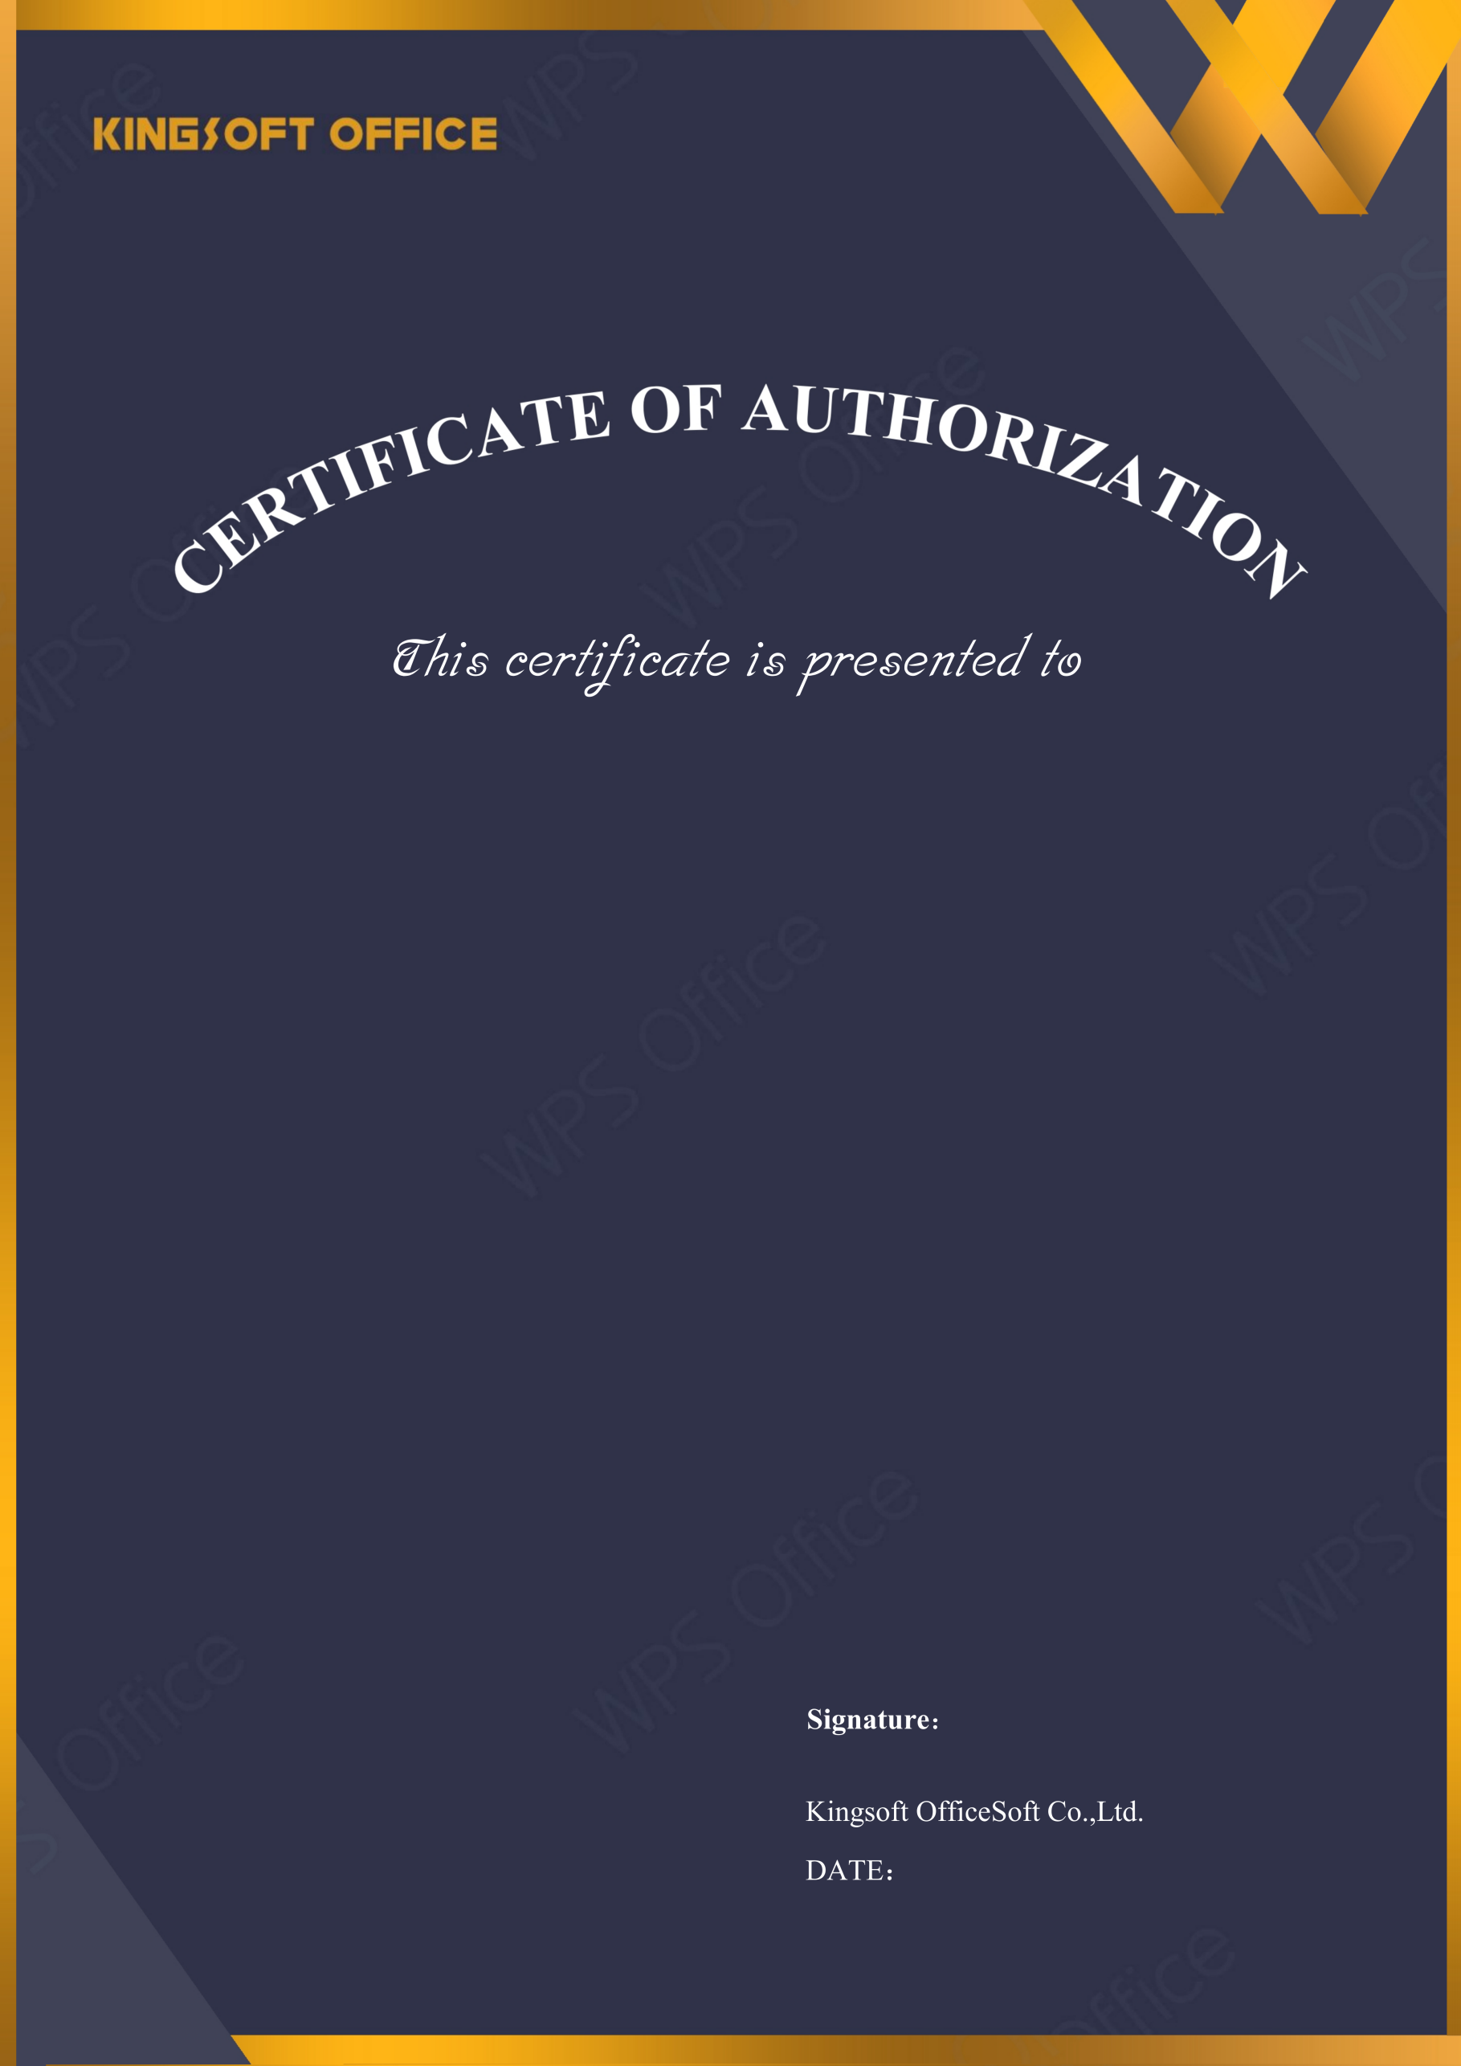
2027-04-07
Ai Energy PCL.

Licensed Software: | WPS Office for Business
License Type: | Quantity License
Licensed Quantity: | 4
License Start Date: | 2026-04-07
License Expire Date: | 2027-04-07
Upgrade Deadline: | 2027-04-07
License Number: | SF1RG-ND1TB-P75B4-SZ5IL-4HXVG



